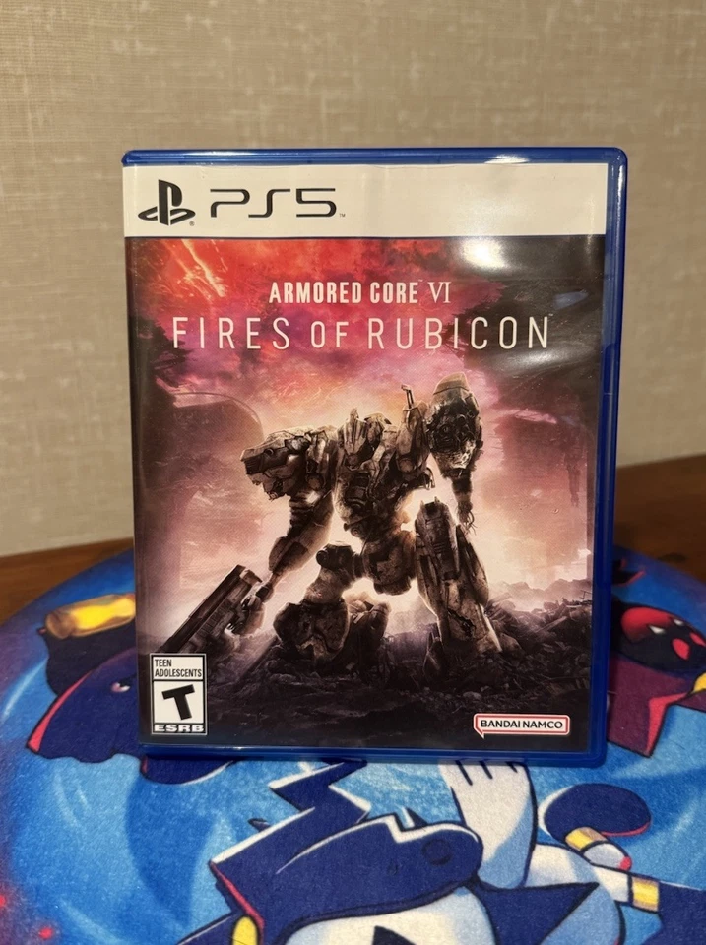

Armored Core VI: Fires of Rubicon:

**1️. Deep Mech Customization**

Players can **custom-build their mechs (ACs)** with a variety of **weapons, armor, and mobility options**, allowing for different combat styles.

**2️.Fast-Paced, Dynamic Combat**

Features **high-speed aerial and ground battles**, combining **ranged gunplay and melee attacks** for intense, strategic fights.

**3️.Engaging Single-Player Story**

Set on **Rubicon 3**, players navigate a war between **megacorporations, rebels, and the government**, making key decisions that affect the outcome.

**4️.Competitive Multiplayer Battles**

Includes **1v1 and 3v3 online modes**, allowing players to **test their custom mechs** against others in high-stakes combat.

**5️. Revival of the Armored Core Series**

The first new **Armored Core** game in **over a decade**, it revitalizes the franchise with **modern graphics, fresh mechanics, and critical success**.